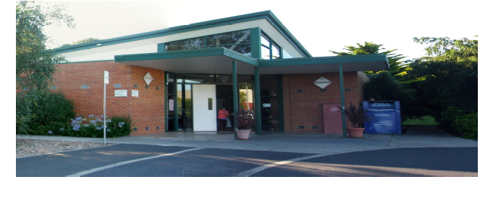
Our Lady of the Pines Parish
The Parish of Our Lady of the Pines deeply respects the Wurundjeri people as the original custodians of this land
77 Carbine Street,
Donvale Vic 3111
Telephone: 9841 8354
E-mail: olopp@bigpond.com
Website: www.ourladyofthepineschurch.org
Parish Office Hours: Mon, Wed and Friday; 8.45am to 4pm
Parish Priest: Fr Jerald Cecil Mariadas. Tel: 0452 567 623
Assistant Priest: Fr Peter Thanh Tran. Tel: 0402 651 979
Pastoral Associate: Mr. John Lazzari

Our Lady of the Pines
77 Carbine Street, Donvale,
Victoria 3111
Tel: 03 9841 8354

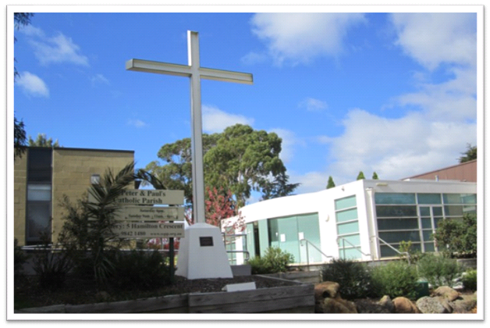
Lenten Daily Prayer

Teach us to pray

One of his disciples said to him, 'Lord, teach us to pray.'
Luke 11:1

Dear God

I'd like to talk to you,
But I’m not sure I have the right words.
I’d like to listen to you,
But I’m not sure what you sound like.

I’d like to come to know you better,
But I’m not sure if I would recognize you.

Please open my eyes,
My ears,
My heart,
To whatever it is
You want me to know about you.
Be with me God,
As I begin this journey of prayer.

Amen.
Write a couple of words expressing how you felt before, during, or after this prayer moment.

………………………………………………………………………………………………………………………………………………………………………
If you wish , pray the Our Father

Day 1

Who will love me for me?
As the Father has loved me, so I have loved you; abide in my love.
John 15.·9
Loving God

When I come before you to pray, help me to be me,
not to pretend or be fake.

Allow me, God , to speak honestly to you about how I see myself
and to share with you my vulnerabilities about
how others might see me.

God , you see how I live my daily life, you know my thoughts,
my desires, my worries.
Everything.

And you still love me, just as I am.

Help me to respond to your love, by loving others just as they are,
not for what they have done,
or what they will become.

Just as they are.

Amen.

These prayers are for use during Lent, one for each day of the week, to be used as as your daily prayer, before meals, daily reflection or when you would like to just have a quiet word with God.
Prayers have been obtained from the Discovering Prayer book issued by Catholic Enquiry Office.
Day 2

Making sense of God

But ask in faith, never doubting, for the one who doubts is like a wave of the sea, driven and tossed by the ·wind ...
James 1:5-8

Dear God

I remind myself that I am in your presence

God, help me to make sense of who you are.
Should I look for signs of your presence, or is it something
I will only know in my head, or is it deeper?
ls it something I will feel in my heart or my gut?

God, help me to make sense of what other people say about you.
Some say only the unintelligent believe in you. Yet others say their
life would be incomplete without you.

God, help me to make sense of what scripture says about you.
Can I trust what is written?

(Take a few moments in silence now. Then speak your own words about any doubts you might have.)

God, help me not to doubt you.

Help my unbelief.

Amen.

Day 3

Why does God let bad things happen?

The human mind plans the way, but the Lord directs the steps. Proverb 1: 16:9

Lord, God

Sometimes I do not understand why things happen the way they do.
How can: little babies die, young people get sick,
storms, floods and droughts take countless live?

Yet, I also see:
the miracle of birth,
the splendid beauty of creation,
kind, loving and generous people throughout the world.

Why, God, do you let these good and bad things happen in life?

Help me to understand your plans are not always
my plans.

Help me to trust, you have it under control.

Lord, I thank you for all the good things that "happen in my life”.

And I ask for your help to. understand and deal with those
things that don't go according to my plan.

Lord, in you I trust.

Amen.

Day 4

Being Vulnerable?

…..but he said to me, My grace is sufficient for you, for power is made perfect in weakness.'
2 Corinthians 12:9

Loving God

Help me to take a gentle look deep inside myself.
(take as long as you like now to acknowledge any hurts you are carrying. Don’t dwell on them, just name them.)

Lord, I find it difficult to open up the wounds of the past.
It would be easier to keep them locked up in a neat and tidy place
within me, so they cause no further pain.

But, God. l cannot lie to myself. I know these wounds will never heal unless I make a decision to do something about them.

Give me the courage to unlock the places in my heart holding
these hurts. Over the coming days let me bring them out into the open
so you can apply your gentle and healing ways.

Give me wisdom, God, to reach out to the right people who can also help in the healing. May l know that l
no longer have to do this alone.

Lord. I know that in my weakness you will make Me strong.

Amen.

Day 5

Sorry seems to be the hardest word?

I'm sorry. In life, we err frequently; we make many mistakes. We all do.
Pope Francis , February 14,2014: St Peter’s Square, Vatican

Forgiving God

In humility, I place myself in a position open to your healing touch.
I am sorry for causing pain; to those I have encountered during my life.

I am sorry that I have not dealt with the consequences of these failings.
I place before you…..
( if you wish , talk to God now about who you need to say sorry to, and then, try to remain silent and allow whatever it is that God wants you to know, to stir the deepest part of your heart)

Help me now, Lord. Show me how to be a person of love.

Show me what l can do to heal the past. And, if it is not possible to
make amends to those I have hurt, help me to know your forgiveness,
your love, your peace.

Amen.

Day 6

Carrying the Cross

As they led him away, they seized a man, Simon of Cyrene, who was coming from the country, and they laid the cross on him, and made him carry it behind, Jesus.
Luke 25:26

Dear Jesus

You know what it is like to carry a cross.

Sometimes I wish I could cast my cross into the ocean,
and continue my journey free of its burden.

But I can't. It is there, day in, day out.
(If you wish, take some time now to speak to God about any crosses you have to bear)

Jesus, help me to understand why you have given me this cross.

Give me courage to carry it, and confidence to ,
ask for help when I sink beneath its weight.

I give you thanks for the loving people who help me to carry my burden.

Let me be gracious in accepting their support.
I surrender myself to your love and mercy.

Amen.

Day 7

Being the best version of Me.

The glory of God is the human person fully alive.
St. Irenaeus.

Loving God

I so desire to be the very best version of me. But sometimes I find that very hard to do. It is so tempting, so easy,
to give into negative ways of living. It is hard to break habits I have developed over the years.

These habits, even though they aren't particularly good, are comfortable. I'm not sure I have the energy to change my ways.

But when I think about it, I would love people to see me in a better light. Help me now, Lord, to acknowledge not only the things I might change, but also those areas where I am pleased with the way I have acted.

[Take a few moments to reflect on the past day- where were
you the best/not the best version of you?]

Holy Spirit, help me not to ignore the stirrings of my heart. Help me to be conscious of my actions, and how I respond to those around me.
Help me to be the very best version of me.

Amen

